practica final pinguins

Laura Chaparro

20/1/2022

<file:///D:/Curso%20R/Practica/Practica%20final%20pinguins/PracticaFinalPinguinsW.html>

#Practica Pinguins Cargamos librerias

library(dplyr)

##   
## Attaching package: 'dplyr'

## The following objects are masked from 'package:stats':  
##   
## filter, lag

## The following objects are masked from 'package:base':  
##   
## intersect, setdiff, setequal, union

library(plyr)

## ------------------------------------------------------------------------------

## You have loaded plyr after dplyr - this is likely to cause problems.  
## If you need functions from both plyr and dplyr, please load plyr first, then dplyr:  
## library(plyr); library(dplyr)

## ------------------------------------------------------------------------------

##   
## Attaching package: 'plyr'

## The following objects are masked from 'package:dplyr':  
##   
## arrange, count, desc, failwith, id, mutate, rename, summarise,  
## summarize

library(ggplot2)  
library(palmerpenguins)

data(package = 'palmerpenguins')  
penguins

## # A tibble: 344 x 8  
## species island bill_length_mm bill_depth_mm flipper_length_mm body_mass_g  
## <fct> <fct> <dbl> <dbl> <int> <int>  
## 1 Adelie Torgersen 39.1 18.7 181 3750  
## 2 Adelie Torgersen 39.5 17.4 186 3800  
## 3 Adelie Torgersen 40.3 18 195 3250  
## 4 Adelie Torgersen NA NA NA NA  
## 5 Adelie Torgersen 36.7 19.3 193 3450  
## 6 Adelie Torgersen 39.3 20.6 190 3650  
## 7 Adelie Torgersen 38.9 17.8 181 3625  
## 8 Adelie Torgersen 39.2 19.6 195 4675  
## 9 Adelie Torgersen 34.1 18.1 193 3475  
## 10 Adelie Torgersen 42 20.2 190 4250  
## # ... with 334 more rows, and 2 more variables: sex <fct>, year <int>

penguins_raw

## # A tibble: 344 x 17  
## studyName `Sample Number` Species Region Island Stage `Individual ID`  
## <chr> <dbl> <chr> <chr> <chr> <chr> <chr>   
## 1 PAL0708 1 Adelie Pengu~ Anvers Torge~ Adult,~ N1A1   
## 2 PAL0708 2 Adelie Pengu~ Anvers Torge~ Adult,~ N1A2   
## 3 PAL0708 3 Adelie Pengu~ Anvers Torge~ Adult,~ N2A1   
## 4 PAL0708 4 Adelie Pengu~ Anvers Torge~ Adult,~ N2A2   
## 5 PAL0708 5 Adelie Pengu~ Anvers Torge~ Adult,~ N3A1   
## 6 PAL0708 6 Adelie Pengu~ Anvers Torge~ Adult,~ N3A2   
## 7 PAL0708 7 Adelie Pengu~ Anvers Torge~ Adult,~ N4A1   
## 8 PAL0708 8 Adelie Pengu~ Anvers Torge~ Adult,~ N4A2   
## 9 PAL0708 9 Adelie Pengu~ Anvers Torge~ Adult,~ N5A1   
## 10 PAL0708 10 Adelie Pengu~ Anvers Torge~ Adult,~ N5A2   
## # ... with 334 more rows, and 10 more variables: Clutch Completion <chr>,  
## # Date Egg <date>, Culmen Length (mm) <dbl>, Culmen Depth (mm) <dbl>,  
## # Flipper Length (mm) <dbl>, Body Mass (g) <dbl>, Sex <chr>,  
## # Delta 15 N (o/oo) <dbl>, Delta 13 C (o/oo) <dbl>, Comments <chr>

View(penguins)  
View(penguins_raw)  
str(penguins)

## tibble [344 x 8] (S3: tbl_df/tbl/data.frame)  
## $ species : Factor w/ 3 levels "Adelie","Chinstrap",..: 1 1 1 1 1 1 1 1 1 1 ...  
## $ island : Factor w/ 3 levels "Biscoe","Dream",..: 3 3 3 3 3 3 3 3 3 3 ...  
## $ bill_length_mm : num [1:344] 39.1 39.5 40.3 NA 36.7 39.3 38.9 39.2 34.1 42 ...  
## $ bill_depth_mm : num [1:344] 18.7 17.4 18 NA 19.3 20.6 17.8 19.6 18.1 20.2 ...  
## $ flipper_length_mm: int [1:344] 181 186 195 NA 193 190 181 195 193 190 ...  
## $ body_mass_g : int [1:344] 3750 3800 3250 NA 3450 3650 3625 4675 3475 4250 ...  
## $ sex : Factor w/ 2 levels "female","male": 2 1 1 NA 1 2 1 2 NA NA ...  
## $ year : int [1:344] 2007 2007 2007 2007 2007 2007 2007 2007 2007 2007 ...

summary(penguins)

## species island bill_length_mm bill_depth_mm   
## Adelie :152 Biscoe :168 Min. :32.10 Min. :13.10   
## Chinstrap: 68 Dream :124 1st Qu.:39.23 1st Qu.:15.60   
## Gentoo :124 Torgersen: 52 Median :44.45 Median :17.30   
## Mean :43.92 Mean :17.15   
## 3rd Qu.:48.50 3rd Qu.:18.70   
## Max. :59.60 Max. :21.50   
## NA's :2 NA's :2   
## flipper_length_mm body_mass_g sex year   
## Min. :172.0 Min. :2700 female:165 Min. :2007   
## 1st Qu.:190.0 1st Qu.:3550 male :168 1st Qu.:2007   
## Median :197.0 Median :4050 NA's : 11 Median :2008   
## Mean :200.9 Mean :4202 Mean :2008   
## 3rd Qu.:213.0 3rd Qu.:4750 3rd Qu.:2009   
## Max. :231.0 Max. :6300 Max. :2009   
## NA's :2 NA's :2

##Pregunta 1 -Número de individuos totales

length(penguins$species)

## [1] 344

-masculinos y femeninos por especie.

ggplot(data = penguins)+  
 geom_count(aes(x= sex, y = species))

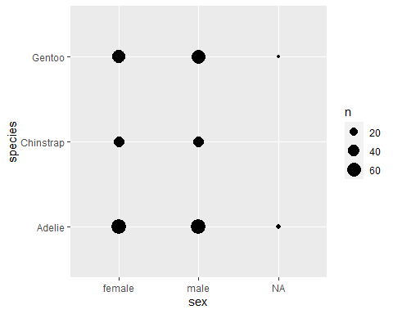

table(penguins$sex, penguins$species)

##   
## Adelie Chinstrap Gentoo  
## female 73 34 58  
## male 73 34 61

Adelie Chinstrap Gentoo female 73 34 58 male 73 34 61

-La media, desviación estándar, valor mínimo y máximo de la longitud y profundidad del pico, la longitud de la aleta y el tamaño.

####media por especie##  
penguins <- na.omit(penguins)  
  
tapply(penguins$bill_length_mm, penguins$species, mean)

## Adelie Chinstrap Gentoo   
## 38.82397 48.83382 47.56807

tapply(penguins$bill_depth_mm, penguins$species, mean)

## Adelie Chinstrap Gentoo   
## 18.34726 18.42059 14.99664

tapply(penguins$flipper_length_mm, penguins$species, mean)

## Adelie Chinstrap Gentoo   
## 190.1027 195.8235 217.2353

tapply(penguins$body_mass_g, penguins$species, mean)

## Adelie Chinstrap Gentoo   
## 3706.164 3733.088 5092.437

#### Desviacion estandar##  
tapply(penguins$bill_length_mm, penguins$species, sd)

## Adelie Chinstrap Gentoo   
## 2.662597 3.339256 3.106116

tapply(penguins$bill_depth_mm, penguins$species, sd)

## Adelie Chinstrap Gentoo   
## 1.219338 1.135395 0.985998

tapply(penguins$flipper_length_mm, penguins$species, sd)

## Adelie Chinstrap Gentoo   
## 6.521825 7.131894 6.585431

tapply(penguins$body_mass_g, penguins$species, sd)

## Adelie Chinstrap Gentoo   
## 458.6201 384.3351 501.4762

#### valor maximo##  
tapply(penguins$bill_length_mm, penguins$species, max)

## Adelie Chinstrap Gentoo   
## 46.0 58.0 59.6

tapply(penguins$bill_depth_mm, penguins$species, max)

## Adelie Chinstrap Gentoo   
## 21.5 20.8 17.3

tapply(penguins$flipper_length_mm, penguins$species, max)

## Adelie Chinstrap Gentoo   
## 210 212 231

tapply(penguins$body_mass_g, penguins$species, max)

## Adelie Chinstrap Gentoo   
## 4775 4800 6300

#### valor minimo##  
tapply(penguins$bill_length_mm, penguins$species, min)

## Adelie Chinstrap Gentoo   
## 32.1 40.9 40.9

tapply(penguins$bill_depth_mm, penguins$species, min)

## Adelie Chinstrap Gentoo   
## 15.5 16.4 13.1

tapply(penguins$flipper_length_mm, penguins$species, min)

## Adelie Chinstrap Gentoo   
## 172 178 203

tapply(penguins$body_mass_g, penguins$species, min)

## Adelie Chinstrap Gentoo   
## 2850 2700 3950

##Pregunta 2 -Un gráfico de barras que represente el número de individuos muestreados de cada especie en cada isla, representando las especies en diferentes colores (chinstrap – morado, gentoo – azul, adelie – naranja).

penguins <- penguins %>%  
 mutate(species = factor(species, levels = c('Adelie', 'Chinistrap', 'Gentoo')))  
  
ggplot(data = penguins) +  
 geom_count(aes(x = island, y = species))

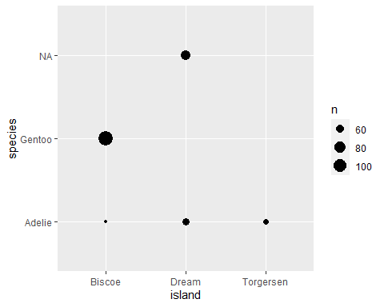

table(penguins$island, penguins$species )

##   
## Adelie Chinistrap Gentoo  
## Biscoe 44 0 119  
## Dream 55 0 0  
## Torgersen 47 0 0

ggplot(data = penguins) +  
 geom_bar(aes(x = island, fill = species))+  
 scale_fill_manual(values = c("orange", "purple", "blue"))

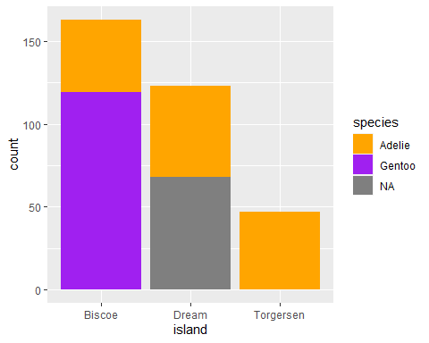

-Contesta a las siguientes preguntas: 1.¿qué especie se ha muestreado en las tres islas? **Adeline** 2.¿cuántos individuos se han muestreado de la isla Dream? **55**

##Pregunta 3 -Un gráfico multipanel de cajas y bigotes del tamaño de los pingüinos según su sexo, donde aparezca un panel para cada especie.

ggplot(data = penguins)+  
 geom_boxplot(aes(x = species, y = body_mass_g, fill = sex ))

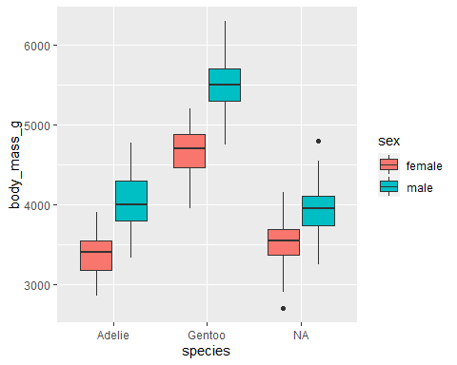

-Contesta a las siguientes preguntas: 1.¿qué especie tiene mayor tamaño? **Gentoo** 2.¿en qué especie las hembras y los machos tienen un tamaño más similar? **Adeline**